ITMan

Document version 1.4

del 21.02.2022

Group #2

TEAM Itmen

Roberto Colella [r.colella17@studenti.uniba.it](mailto:r.colella17@studenti.uniba.it)

Giovanni Forleo [g.forleo3@studenti.uniba.it](mailto:g.forleo3@studenti.uniba.it)

Paolo Gasparro [p.gasparro4@studenti.uniba.it](mailto:p.gasparro4@studenti.uniba.it)

Giuseppe Piccininni [g.piccininni5@studenti.uniba.it](mailto:g.piccininni5@studenti.uniba.it)

**Do it safe**

Index

1 Planning – Game Overview 3

1.1 Goal of the Game 3

1.2 Target Audience 3

1.3 Game Genre(s) 4

1.4 Constraints 4

1.4.1 Platform 4

1.4.2 Budget 4

1.4.3 Timetable 4

1.5 Look and Feel 5

1.6 Resources 6

1.7 Game Flow Summary 7

2 Design 8

2.1 Mechanics 8

2.1.1 Space 8

2.1.2 Objects 8

2.1.3 Actions 12

2.1.4 Rules 12

2.1.5 Skills 13

2.1.6 Chance (Easter eggs) 14

2.2 Story 15

2.2.1 Characters 15

2.3 Aesthetics 16

2.3.1 Mission/challenge Structure 16

2.3.2 Levels 18

3 User test 23

3.1 Description of the user test 23

3.2 Execution of the test 23

3.3 Type of testing users 25

3.4 Analysis of the user test 26

4 Conclusion and future developments 29

5 References 30

# Planning – Game Overview

## Goal of the Game

The goals of the game are oriented to learn some of the main topics about cybersecurity. In particular these goals are specific to understand what are the best practices about data security. The game consists of the sequent goals:

* Primary
  + Define the concept of security password
  + Define the concept of free Wi-fi
  + Define the concept of security camera
  + Define the concept of spoofing
  + Define the concept of tailgating
* Secondary
  + Kill the enemies of the level
  + Complete the level in a certain number of moves
  + Collect Bitcoin moneys

The primary goals are specific for single level. The secondary goals are long term goals because every level is characterized by specific secondary goals.

## Target Audience

The game can be played by everybody even without specific skills in cybersecurity. Anyway, the team decided to design the target audience properties, in the **Table 1**

|  |  |
| --- | --- |
| **Item** | **Average learners** |
| Age | 15-45 |
| Educational level | High School |
| Reading level | Good |
| Motivation | Medium |
| Prerequisite Knowledge | Good puzzle solving ability and low cybersecurity knowledge |
| Prerequisite Skills | * mouse and keyboard * logic ability |
| Facility with a computer | Low |

**Table 1: Target Audience**

## Game Genre(s)

The game can be classified as:

* Board game: the user moves the character like a pawn in a board.
* Strategic game: the user moves the character using a turn-based strategy, and every movement corresponds to a movement of the enemies. To complete the level, the user moves the character without being killed by the enemies and gets the end point of the board.
* Puzzle game: during the game, there are different cybersecurity enigmas to solve the levels.

## Constraints

### Platform

The platform for which game will be developed is the PC.

### Budget

The project will be developed in two/three months approximately.

### Timetable

After a brainstorming, the team has decided to follow the schedule written below. Anyway, this plan is still temporary and sketchy so it could be changed during the development of the game:

* In the first two weeks the team defined the goals of the game, target audience and the resources must be definitively designed. The main cybersecurity topics must be chosen and designed in a “serious way” through the game levels, that are going to be only designed in this phase using some techniques like sketches
* Next, the team has retrieved all the necessary resources to develop the game (learning how Unity Editor works, finding graphical assets). In this phase the team has divided the tasks based on the skill of the components and has created a repository using a versioning code tool (GitHub)
* In the remaining time, the game has been developed using an iterative workflow, testing each level after implementing it

The final product has been ready approximately in January/February 2022.

## Look and Feel

***ITman*** follow the philosophy of the videogame’s series “GO”, especially *Hitman GO*. The idea is to let the player to guide a character through a series of grid-based levels. The environment is presented like a board game with characters modelled as miniature figures. **Figure 1**

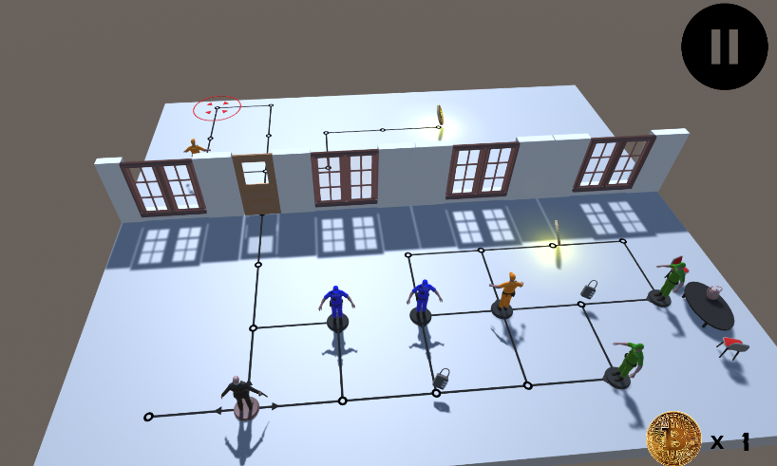

**Figure 1: ITman board**

## Resources

* Roberto Colella: Game designer
* Giovanni Forleo: Game designer
* Paolo Gasparro: Game designer
* Giuseppe Piccininni: Game designer
* Topic to be covered:
  + Security password
  + Free Wi-fi
  + Security camera
  + Spoofing
  + Tailgating
* Content delivery: Videogames
* Hardware (CPU+GPU):
  + Intel i9-9900KF - Nvidia RTX 2070
  + Intel i5-8250U – Intel UHD 6000
  + Intel i7-10750H – Nvidia RTX 3070
  + AMD Ryzen 5 5600X – Nvidia GTX 1050Ti
* Software: Visual Studio community 2019, Unity editor 2019.4.31f, Git hub





## Game Flow Summary

The game has several levels regarding the following topics:

* Security password
* Free Wi-fi
* Security camera
* Spoofing
* Tailgating

Every level is composed by the following four parts:

* Introduction screen: here it is shown the title, the description and the topic of the level
* Security Tip: at the end of the board game session (which is illustrated in the next point) the user is able to see the tip of the level which is a suggestion and a good practice about the topic addressed in the level
* Board game: this is the board where the user plays the game, can pick up bitcoin moneys and in general makes operations to complete the level. If during the level the user picks up 2 bitcoins, he will receive an additional security tip (which is different from the one received when completing the level)
* Secondary Goals: they consist in two additional goals that the user may or may not have achieved during the level (e.g., completing the level in less than a certain number of moves)

The difficulty of every single level is defined by the user strategy used to complete it by using specific moves.

# Design

## Mechanics

Mechanics represents the most important element of the serious game. In particular the **space**, the **objects** that the user uses in the serious game, the **actions** that can be done, all the game **rules**, all elements **chance** and the **skills** necessary for playing.

### Space

The space represents a fictional world, where the user moves the main character (Agent 47), into a specific board to solve issues regarding cybersecurity useful to complete his training. In terms of functionalities and learning, the game space guides the user showing different pills about cybersecurity with the use of tips. The game space supports and facilitates the gameplay with the presence of animation and colors to identify what are the characteristics of the enemies.

The space consists in discreet positions and a linear arrangement because the users can understand where they are situated in the board. All levels have an end point, that represents the finish line to reach to conclude the level. The space guides the players forcing the user to use different components of the game to arrive to the end of the level. The freedom of every level is provided by the possibility, for the user, to move the character on different nodes to reach the end of the level (it means that there are multiple paths from the start to the end of the level).

### Objects

The objects are the elements of the serious game which the player interact for the gameplay. **Table 2**

|  |  |  |  |  |  |
| --- | --- | --- | --- | --- | --- |
| **Image** | **Object** | **Attributes** | **Impact on the player’s learning** | | **Impact on the player’s experience** |
|  | Agent 47 | Black | Use the character to resolve cyber-security puzzle | Allows the user to play the game | |
|  | Spyware | Blue | Defines possible security problem | Obstacles the user | |
|  | Worm | Orange | Defines possible security problem | Obstacles the user | |
|  | Trojan | Green | Defines possible security problem | Obstacles the user | |
|  | Camera | Grey, produces a light red if is malicious, green if is good | Helps to learn the concept of security camera | It represents an obstacle to complete the level | |
|  | Padlock | Grey | Allows to learn the security aspect of the password | | Contains a suggestion for the password of the level to guess |
|  | Terminal | Terminal object: Grey | Introduces the concept of stealing credentials | Allows to steal user’s credentials | |
|  | Terminal screen | Terminal screen: green and black |
|  | Doors | Grey or brown | Allows to improve the security password concept | It represents an obstacle to overcome to complete the level | |
|  | Key pad | Grey with button numbers | Allows to insert the password to unlock a door | | It represents a way to learn the concept of password |
|  | Computer | Grey | Allows to improve the security password concept | It represents a way to learn the concept of security camera and the potential risks of using free Wi-Fi | |
|  | Computer screen | Black, red and grey | Allows to insert the credentials to disable the cameras |
|  | Bitcoin | Gold yellow | By collecting two moneys, the user can receive an extra cybersecurity tip | | Creates longevity in the serious game |
|  | Jacket | Orange | Introduces the concept of tailgating | | Its use allows the user to complete the game |
|  | End Level node | Red | It represents the end point of the level | By reaching it, the user completes the level | |
|  | Node | Black | Allows the user to move the character | Allows the user to move the character | |

**Table 2: objects of the serious game**

### Actions

During the game the user can move the character right, left, up or down in the board. The movements are defined by the keyboard arrow keys. With the use of the mouse the user can click either on a terminal or on a computer to show tips useful to complete the level.

### Rules

The rules of the game are operational, constitutive and implicit rules.

The **operational** rules are:

* The player moves the character using the keyboard rows keys
* The player moves the character on different nodes of the board
* The player interacts with the objects by moving the character on the node close to them
* The player reaches the end point to complete the level
* The player takes two bitcoins to display an extra tip
* The player takes a padlock to receive a suggestion about the level password
* The player can open a door in multiple ways depending on the situation and so on the level he’s playing:
  + inserts the right password that unlocks the door (level 1)
  + picks up a key killing an enemy and uses it to unlock the door (level 3)
  + goes on the node on which the door is placed after wearing the enemy jacket (level 4)
* The player mustn’t go under the camera’s red light when he’s wearing Agent 47’s clothes (level 4)
* The player mustn’t go under the camera’s red light (level 2)
* The player can go under the camera’s green light (level 2)
* The player inserts the credentials in the PC or in the terminal by using keyboard and mouse (level 2 and level 3)
* The player kills the enemies going on the node where the enemy is located but only when the player and the enemy are positioned on two adjacent nodes and the player plays the next turn. In case, instead, the enemy plays the next turn then we have two different situations based on the position of enemy:
  + the player is in front of the enemy when he moves the character: the enemy kills the player
  + the player is behind, to the left or to the right of the enemy when he moves the character: the enemy cannot kill the player

The **constitutive** rules are:

* The player moves the character on a node from which the enemies cannot kill him
* The player completes the level in a certain numbers of steps
* The player completes the level and kills all enemies in the level

The **implicit** rules are:

* The player wins the level if reaches the end point without dying
* The player moves in a different direction to get an achievement
* The player moves in different direction to look for a good way to complete the level

During the game there are other two type of rules:

* Rules punishments:
  + every time that the player is in a node from which the enemy can kill him
* Rules rewards:
  + if the player takes two *bitcoins* in the same level, he receives an extra security tip
  + if the player completes the level reaching the *end point*, he receives a cybersecurity tip
  + if the player completes the level satisfying some conditions that differ level from level (e.g., complete the level within a certain number of moves or kills all the enemies) he receives a green badge at the end of the level

### Skills

To play the game the following skills are required:

* Ability of using keyboard and mouse
* Base knowledge about cyber-security concepts
* Base knowledge about Computer Science

To continue playing the game and to complete the game, learning the cyber-security concepts of the previous step is mandatory.

### Chance (Easter eggs)

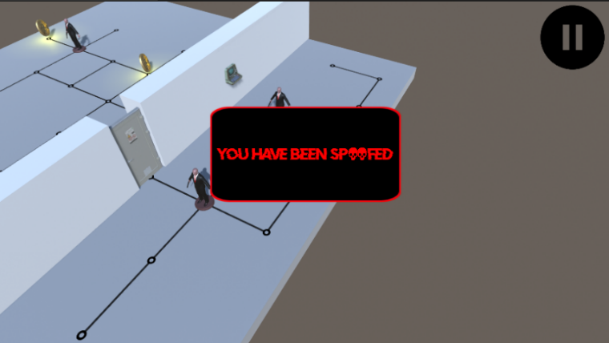As it is well known, chance has always fascinated players since not all the factors in a game should be foreseen or estimated. In ITMAN, chance has been introduced in a tiny way in order to let the player feel a bit or suspense and excitement, to keep him hooked on the game.

Nevertheless, the gameplay drives the player to complete the level and to avoid boringness and flattening, the team decided to introduce some little elements of surprise.

The alarm (**Figure 2**) in the level 3, for example, is an outcome that the player would certainly not expect, and it would scare him. Immediately after this alarm, all the enemies take the appearance of the character, and this is also a surprise element.

**Figure 2 : screen of spoofing alarm**

Another example of chance stays in the fact that, in the level 1, the password to guess by the user is not always the same but changes each run of the game. On each run indeed, it is randomly chosen an array of the 6 possibilities between 4 possible arrays:

* The first array contains all the 6 passwords that terminate with the digit 1
* The second array contains all the 6 passwords that terminate with the digit 2
* The third array contains all the 6 passwords that terminate with the digit 3
* The fourth array contains all the 6 passwords that terminate with the digit 4

So supposing the game has randomly chosen, in this run, the array with the passwords that terminate with the digit 3, then it is randomly selected one password between the 6 belonging to that array, and that one becomes the password to guess by the user.

Of course even the clue in the level changes as the array password changes.

Each cybersecurity tip is randomly chosen, so each player of the game could retrieve different cybersecurity suggestions. **Figure 3**

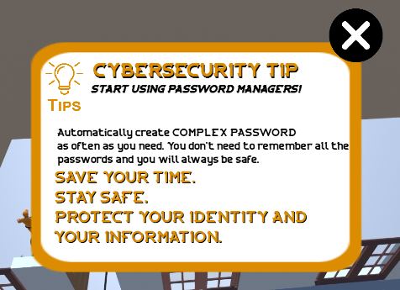

**Figure 3: Example of cybersecurity tip**

Moreover, the password in the Level1 is randomly chosen (between four sets) after each run.

The team decided to do this to make the challenge more engaging for the player.

## Story

The story of the game concerns a security agent, called Agent 47, who performs a training course aimed to learn new techniques about cybersecurity-based espionage. The story is introduced in the training level. **Figure 4**

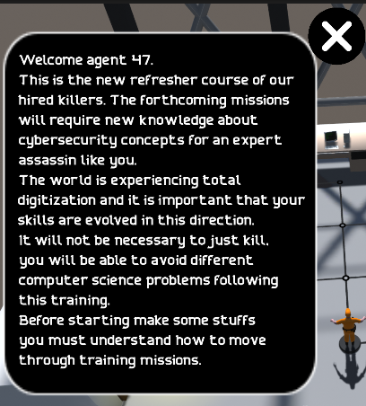

**Figure 4: Introduction of the story**

### Characters

The characters of the game are:

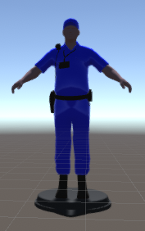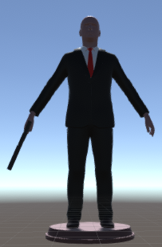

**Agent 47**: the main character of the game. He can move in the level from a starting point to the end of the level, learning cyber-security tips.

**Spyware**: the enemy that can turn around on the place. If Agent 47 is in front of the enemy the level fails because the Spyware kills him.

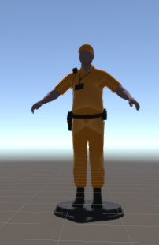**Worm**: the enemy that moves in straight direction. If Agent 47 is in front of the enemy the level fails because the Worm kills him.

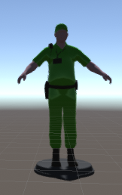**Trojan**: the enemy that stays in position. If Agent 47 is in front of the enemy the level fails because the Trojan kills him.

## Aesthetics

Aesthetics are related to the look and feel of a game. In this serious game the aesthetics are based on *Hitman GO* Aesthetics (e.g., Aesthetics consists to define enemies with different colors and the end of single level by a red node). To be more inclusive the idea is to use a color as neutral as possible.

In different level there are different audios and sounds to create a suspense environment and to make the user feel involved in the story of the serious game.

### Mission/challenge Structure

The mission of the serious game can be divided in:

* 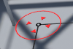**Finish the level**: Defined from a red node in the map. The player goes in this red node to complete the level. **Figure 5**

**Figure 5: End level node**

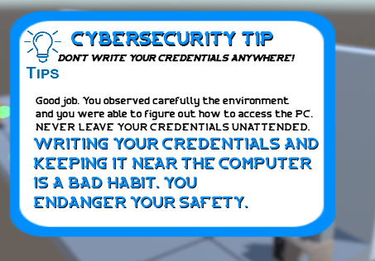

* **End level cybersecurity tip**: After the level, a suggestion about the topic of the level is proposed by using a card with a blue edge. **Figure 6**

**Figure 6: End Level cybersecurity tip**

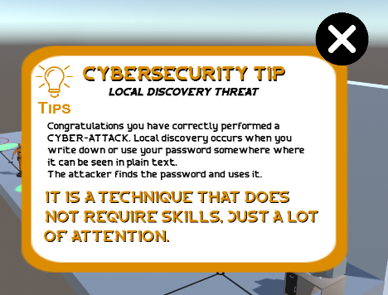

* **Take extra tip**: The extra tip are suggestions used to define good practice of cybersecurity. In this serious game the extra tips are defined by a card with yellow board. **Figure 7**

**Figure 7: Extra cybersecurity tip**

* **Achieve goal**: the goals are other elements of the serious game. In particular are based on:
  + Complete the level in a certain number of moves (level 1, level 2 and level 4)
  + Kill all enemies in the level (level 3 and level 4)
  + Don’t be spoofed from the malware program (level 3)
  + Don’t use the clues (level 1)
  + Guess the credentials on the first try (level 2)

The goals are defined in a card with red and black borders that can be seen when completing the level. If the goal has been achieved, then there is a green circle with a white check; if not, there is a red circle with a with a white cross. An example of the screen described is shown in the figure below (in the right corner we can also see the number of bitcoins picked up). **Figure 8**

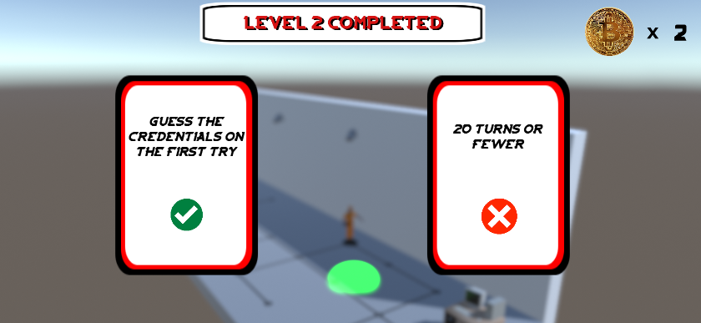

**Figure 8: End level screen**

### Levels

The serious game is composed by 5 levels.

#### Training level

##### *Objective*

The objectives of this level are:

* introduce the movement of the user
* define who are the enemies
* define what are the bitcoin moneys

##### *Storyboard*

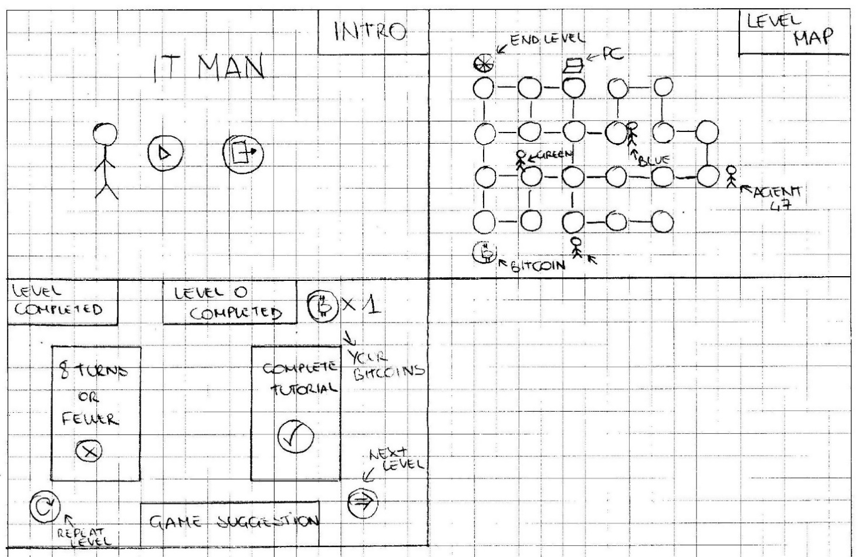

#### Level one

##### *Objective*

The objective of this level is to introduce the concept of security password.

##### *Storyboard*

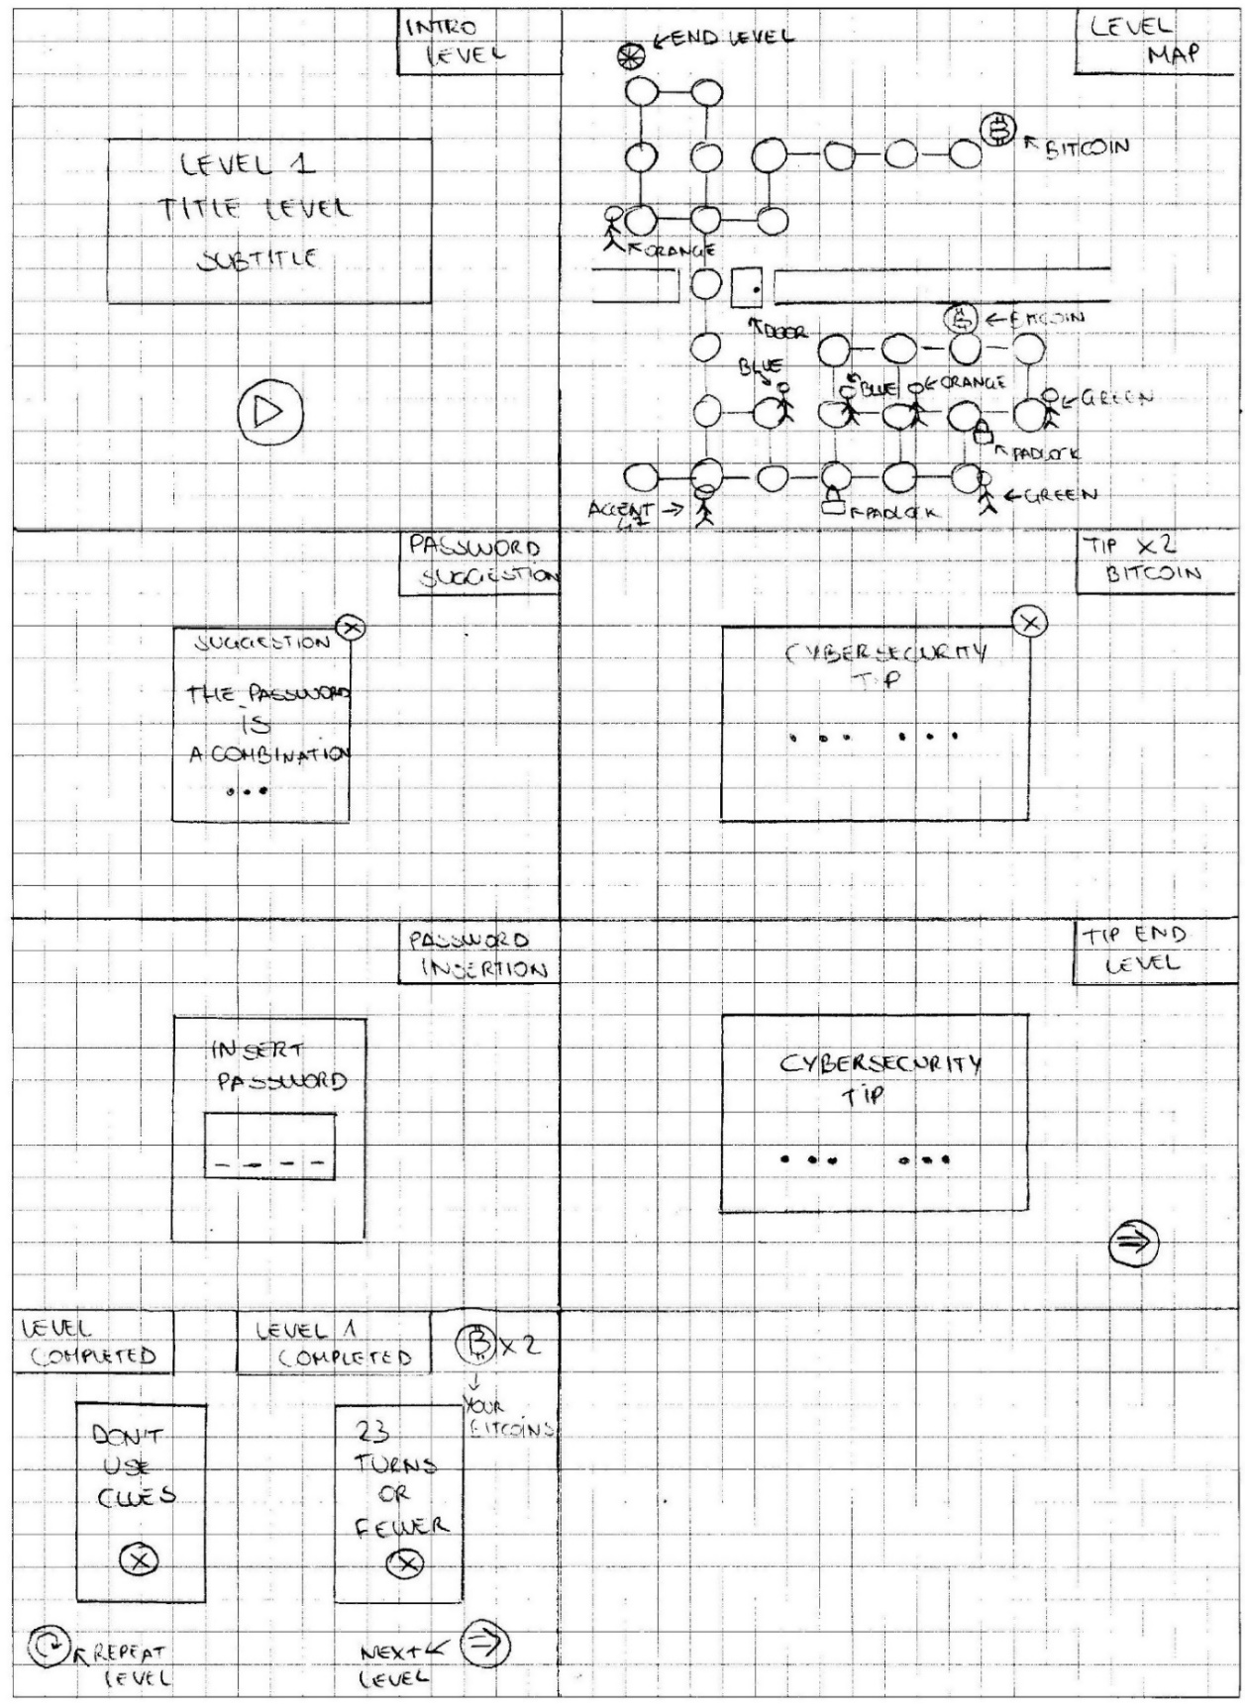

#### Level two

##### *Objective*

The objective of this level is to introduce the risks of using free Wi-Fi and the concept of security cameras.

##### *Storyboard*

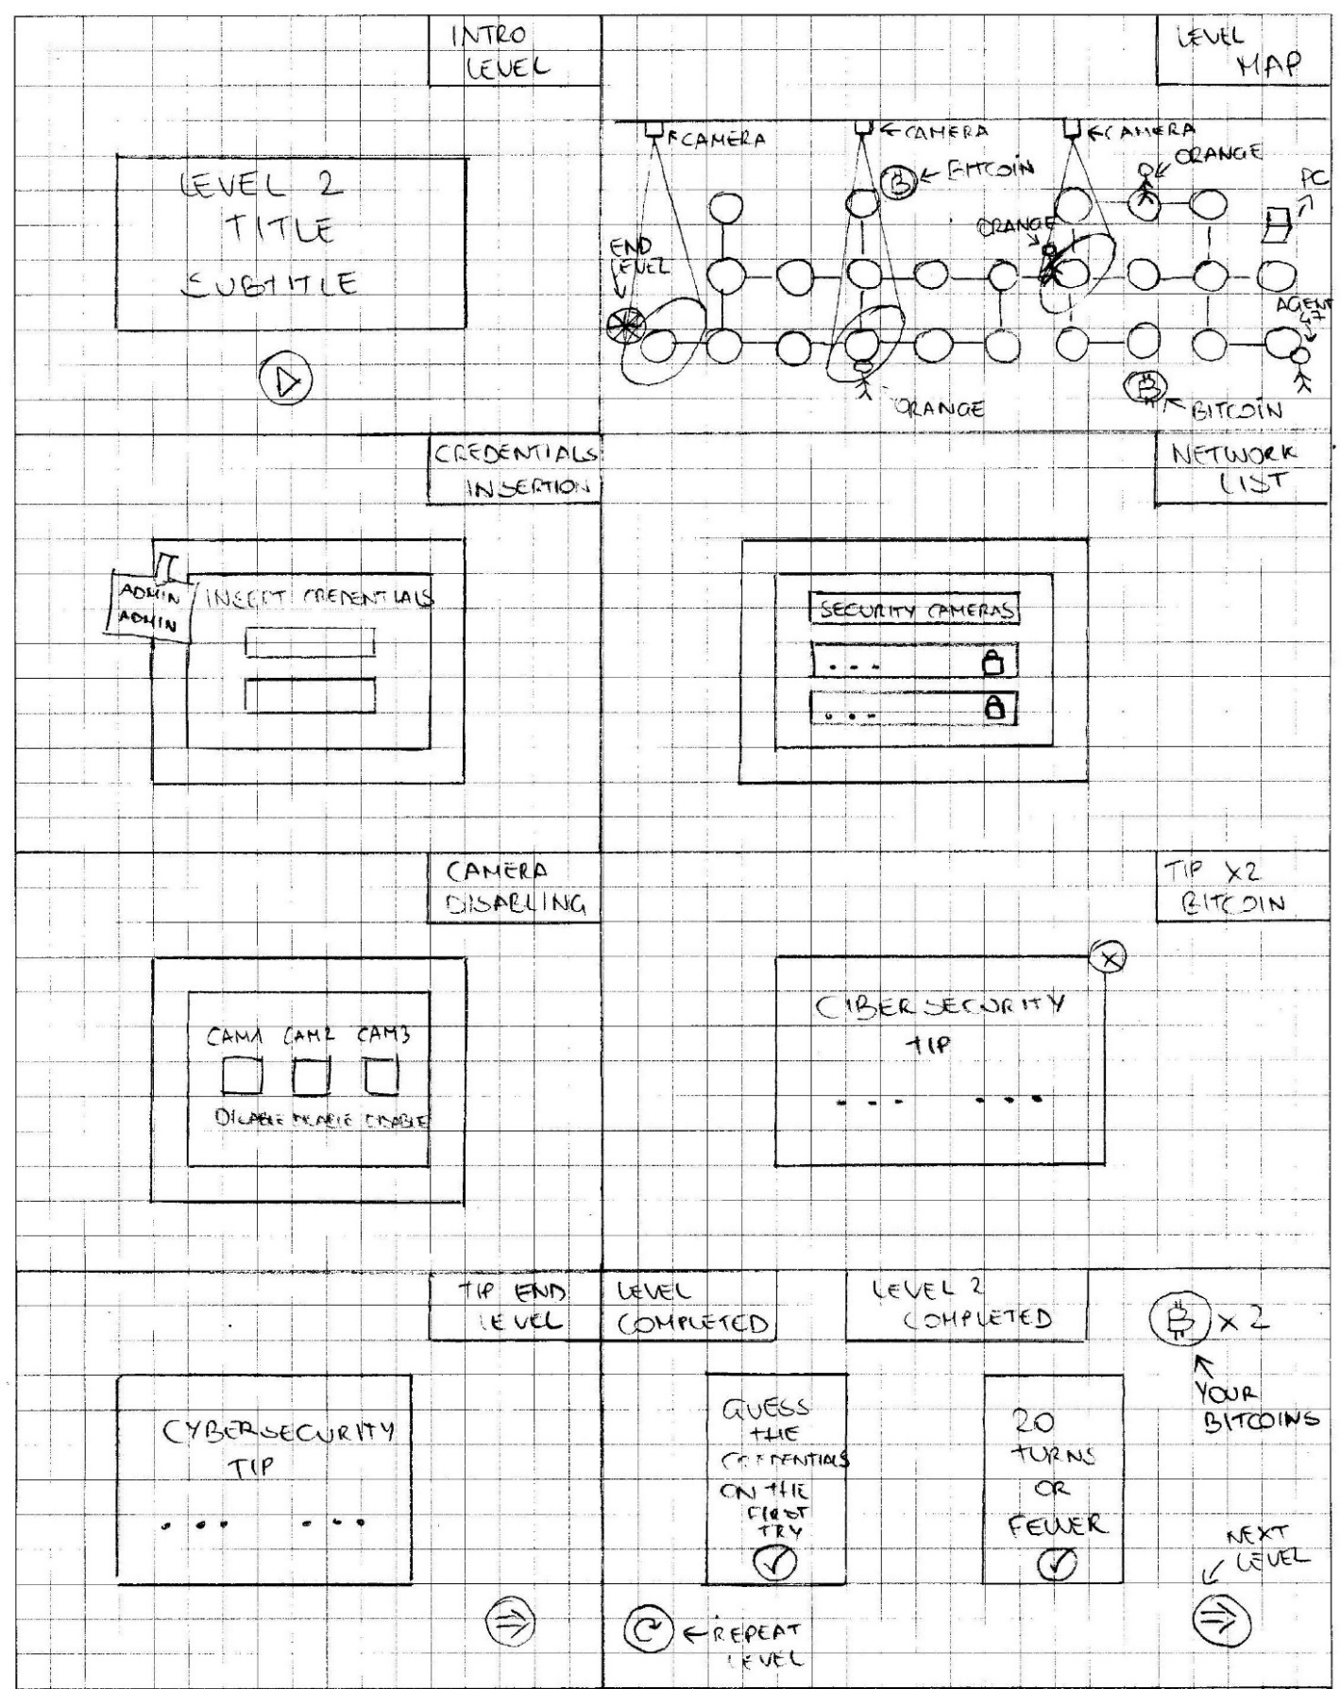

#### Level three

##### *Objective*

The objective of this level is to introduce the concept of Spoofing. Spoofing is a type of cyber-attack which uses identity falsification (spoof) in various ways. Spoofing can occur at any level of the ISO/OSI stack and can also involve the falsification of application information.

##### *Storyboard*

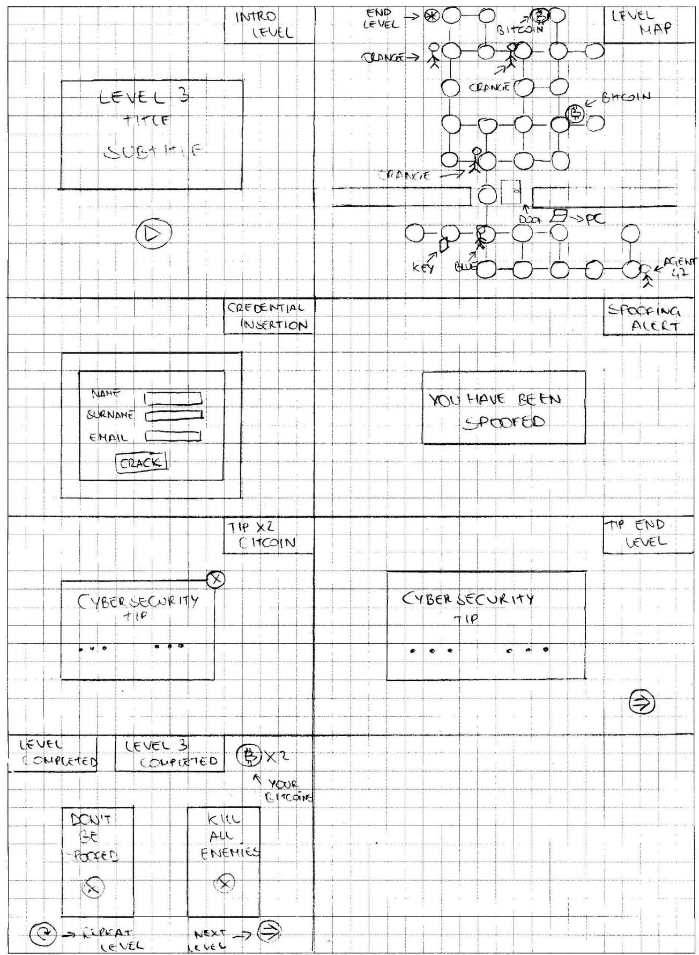

#### Level four

##### *Objective*

The objective of this level is to introduce the context of tailgating. Tailgating is a simple social engineering attack which enables hackers to gain access to a password-protected or otherwise off-limits physical location. Tailgating involves closely following an authorized person into a restricted access area.

##### *Storyboard*

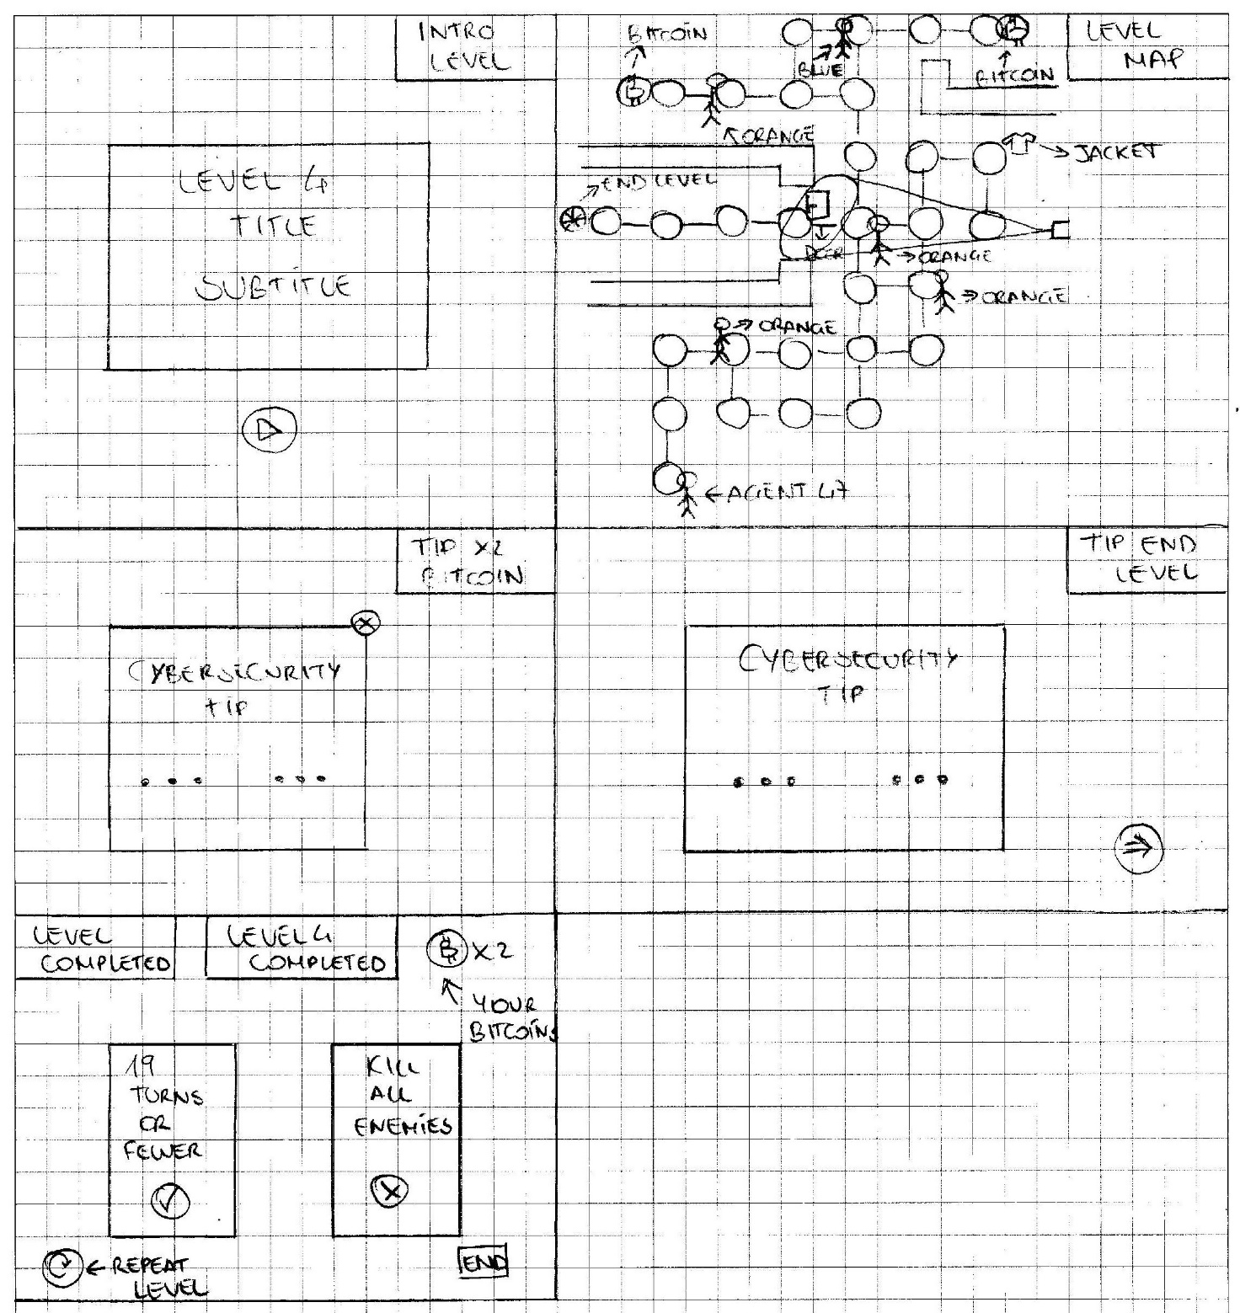

# User test

User testing is a process through which the interface and functions of an application are tested by real users who perform specific tasks in realistic conditions. The team has performed this methodology to evaluate if the serious game’s levels are suitable for the target audience.

## Description of the user test

The user test has been developed with a sample of 7 people with the characteristic defined in target user paragraph. (**Section 1.2**)

Each user was asked to perform some tasks and compile a SUS and QUIS questionnaire.

## Execution of the test

The tasks have been defined for specific Level. The user test composed in these parts:

1. Define at the user the scope of the usability test

2. The user compiles a questionary for him information in anonymous mode.

3. The user executes the level 0 to understand the element of the serious game

4. The user does the test about the four level with specifics tasks

5. The user compiles a questionnaires QUIS and SUS

In specifying, to the first, introduced the scope of the user test, describing the goal of the test for a preparation phase, reassuring the user that the test don’t use to define the capacity of him. Subsequently the user compiles a questionary for him information in anonymous mode. The questionary composed by the anonymous request about:

* The age
* The sex
* The High school
* The knowledge of puzzles
* Knowledge of cybersecurity
* If he/she can use mouse and keyboard
* If he/she can understand logic concepts

Next, the user plays the level zero to learn the main aspects of the serious game in particular how to move the character, who are the enemies and how the bitcoin and object have to be used.

Then, he starts the complete test on the level 1, 2, 3, 4 each one has specific tasks. **Table 3**

|  |  |  |  |  |
| --- | --- | --- | --- | --- |
| **Task** | **Level** | **Goal** | **Output** | **Task during the preparation** |
| Take all bitcoins (1-2-3-4) | 1 | Take all bitcoins in a specific level | Take all bitcoins | Locate the bitcoins |
| 2 |
| 3 | Take the bitcoins |
| 4 |
| Take all padlock (5) | 1 | Take all padlock | Take all padlock | Locate the padlock |
| Take the padlock |
| Kill three blue enemies, two green enemies and two orange enemies  (6) | 1 | Kill the enemies | Kill the enemies | Locate the enemies |
| Kill the enemies |
| Complete the level in 23 steps or fewer  (7) | 1 | Complete the level in 23 steps or fewer | Complete the level in 23 steps or fewer | Complete the level in 23 steps or fewer |
| Don’t use the clues  (8) | 1 | Cross the door without using the clues | Cross the door without using the clues | Locate the door |
| Insert the password in the key pad |
| Cross the door without using the clues |
| Disable all camera  (9) | 2 | Disable all camera | Disable all camera | Locate the PC |
| Reach the PC |
| Access to the system by using credentials |
| Access to the camera network |
| Disable all camera |
| Guess the credential on the first try  (10) | 2 | Guess the credential on the first try | Guess the credential on the first try | Locate the PC |
| Reach the PC |
| Read the credentials on the post-it on the terminal |
| Access at the system with password |
| Complete the level in 20 steps of fewer  (11) | 2 | Complete the level in 20 steps of fewer | Complete the level in 20 steps of fewer | Complete the level in 20 steps of fewer |
| Kill all the enemies  (12-13) | 3 | Kill all the enemies | Kill all the enemies | Locate the enemies |
| Kill all the enemies |
| 4 | Locate the enemies |
| Kill all enemies |
| Don’t get spoofed  (14) | 3 | Don’t use the terminal | Don’t use the terminal | Don’t use the terminal |

**Table 3: task of the test**

After this part the users compiles the QUIS and SUS questionary.

## Type of testing users

There are 7 type of users that tested the game. **Table 4**

|  |  |  |  |  |  |  |  |
| --- | --- | --- | --- | --- | --- | --- | --- |
|  | **Age** | **Sex** | **Educational level** | **Knowledge of puzzles** | **Knowledge of cybersecurity** | **If he/she can use mouse and keyboard** | **If he/she can understand logic concepts** |
| **User 1** | 31 | Male | Bachelor Degree | Yes | Yes | Yes | Yes |
| **User 2** | 17 | Female | High school | Yes | No | Yes | Yes |
| **User 3** | 45 | Male | High school | Yes | Yes | Yes | Yes |
| **User 4** | 25 | Female | Bachelor Degree | Yes | No | Yes | Yes |
| **User 5** | 30 | Male | Bachelor Degree | Yes | Yes | Yes | Yes |
| **User 6** | 15 | Female | High school | Yes | Yes | Yes | Yes |
| **User 7** | 22 | Male | High school | Yes | No | Yes | Yes |

**Table 4: description of the users**

## Analysis of the user test

In this phase are collected all results of the activity of the users. The table represents all the results of the task. With “R” define the result, Success (S), Partial (P), Failed (F). With “T” the time use to do the task. **Table 5**

|  |  |  |  |  |  |  |  |  |  |  |  |  |  |  |
| --- | --- | --- | --- | --- | --- | --- | --- | --- | --- | --- | --- | --- | --- | --- |
| Task | Users | | | | | | | | | | | | | |
| 1 | | 2 | | 3 | | 4 | | 5 | | 6 | | 7 | |
| R | T | R | T | R | T | R | T | R | T | R | T | R | T |
| 1 | S | 1’00’’ | S | 1’00’’ | S | 1’00’’ | S | 1’50’’ | S | 1’10’’ | S | 1’00’’ | S | 1’10’’ |
| 2 | S | 49’’ | S | 39’’ | S | 50’’ | S | 52’’ | S | 48’’ | S | 40’’ | S | 38’’ |
| 3 | S | 50’’ | S | 30’’ | S | 60’’ | S | 40’’ | S | 30’’ | S | 37’’ | S | 40’’ |
| 4 | S | 58’’ | F | 33’ | F | 33’’ | P | 45’’ | P | 37’’ | P | 38’’ | S | 40’’ |
| 5 | S | 31’’ | S | 20’’ | S | 28’’ | S | 27’’ | P | 27’’ | P | 29’’ | S | 35’’ |
| 6 | S | 1’25’’ | S | 43’’ | S | 1’23’’ | S | 2’24’’ | S | 2’12’’ | S | 1’24’’ | S | 1’25’’ |
| 7 | F | 5’50’’ | S | 3’30’’ | S | 3’30’’ | F | 1’52’’ | S | 3’53’’ | F | 1’21’’ | F | 1’23’’ |
| 8 | F | 4’60’’ | S | 3’30’’ | S | 3’30’’ | F | 1’52’’ | F | 3’53’’ | F | 1’21’’ | F | 1’23’’ |
| 9 | S | 19’’ | S | 17’’ | S | 18’’ | P | 30’’ | P | 40’’ | S | 18’’ | S | 17’’ |
| 10 | S | 12’’ | S | 11’’ | S | 12’’ | S | 15’’ | P | 24’’ | P | 23’’ | S | 15’’ |
| 11 | F | 3’60’’ | S | 45’’ | S | 49’’ | F | 4’50’’ | F | 3’50’’ | S | 55’’ | S | 1’10’’ |
| 12 | S | 57’’ | S | 28’’ | S | 40’’ | S | 1’00’’ | S | 1’10’’ | S | 26’’ | S | 27’’ |
| 13 | S | 50’’ | S | 27’’ | S | 40’’ | F | 24’’ | S | 40’’ | S | 30’’ | S | 50’’ |
| 14 | F | 50’’ | S | 30’’ | F | 25’’ | S | 30’’ | F | 34’’ | F | 35’’ | S | 35’’ |

**Table 5: Result of the tests**

Total of tasks: 98

Total success result: 78

Partial success result: 9

Failed result: 19

Rate of total success task: ((R*1)+(P*0.50)+(F*0))/14=((70*1)+(9*0.50)+(19*0))/98=0.7842=78.42%

The rate of the competition is near the 80%. Analyzing the activities in the tests, it can be seen that the remain percentage rate is about the problem of thetask 8**,** because the users were impatient to try all the possible sequences of the password to guess to cross the door.

These problems aren’t solvable because the insertion of the password is a part of the gameplay used to define the cybersecurity aspect of the password.

The problem of the task 4 happens because the camera in the level 4 doesn’t allow to locate the bitcoin in the level easily.

QUIS - Questionnaire for User Interface Satisfaction. **Table 6**

|  |  |  |  |  |  |  |  |
| --- | --- | --- | --- | --- | --- | --- | --- |
| Questions | Values of QUIS | | | | | | |
| User 1 | User 2 | User 3 | User 4 | User 5 | User 6 | User 7 |
| 1 | 4 | 4 | 5 | 3 | 3 | 3 | 5 |
| 2 | 4 | 5 | 4 | 4 | 3 | 3 | 4 |
| 3 | 4 | 5 | 5 | 4 | 2 | 3 | 4 |
| 4 | 4 | 5 | 4 | 3 | 3 | 3 | 4 |
| 5 | 4 | 5 | 4 | 3 | 3 | 3 | 3 |
| 6 | 5 | 5 | 5 | 5 | 5 | 5 | 5 |
| 7 | 4 | 4 | 4 | 4 | 4 | 4 | 4 |
| 8 | 5 | 5 | 5 | 5 | 4 | 4 | 5 |
| 9 | 5 | 4 | 4 | 4 | 4 | 4 | 5 |
| 10 | 5 | 5 | 5 | 5 | 5 | 5 | 5 |
| 11 | 4 | 4 | 4 | 4 | 3 | 3 | 4 |
| 12 | 5 | 5 | 5 | 5 | 5 | 5 | 5 |
| 13 | 4 | 5 | 4 | 4 | 4 | 4 | 5 |
| 14 | 4 | 4 | 4 | 3 | 3 | 3 | 4 |
| 15 | 5 | 5 | 5 | 5 | 5 | 5 | 5 |
| 16 | 4 | 4 | 4 | 3 | 3 | 3 | 4 |
| 17 | 4 | 4 | 4 | 3 | 3 | 3 | 4 |
| 18 | 4 | 5 | 4 | 3 | 3 | 3 | 4 |

**Table 6: QUIS results**

Analyzing the answer in the QUIS questionnaire it can be noticed that the users, in average, have found the application in line with their expectations despite the difficulties encountered.

SUS – System usability scale. **Table 7**

|  |  |  |  |  |  |  |  |
| --- | --- | --- | --- | --- | --- | --- | --- |
| Questions | Values of SUS | | | | | | |
| User 1 | User 2 | User 3 | User 4 | User 5 | User 6 | User 7 |
| 1 | 4 | 5 | 4 | 2 | 2 | 2 | 4 |
| 2 | 4 | 5 | 4 | 2 | 2 | 2 | 4 |
| 3 | 4 | 5 | 4 | 3 | 3 | 3 | 4 |
| 4 | 5 | 5 | 5 | 2 | 2 | 2 | 5 |
| 5 | 4 | 4 | 4 | 1 | 1 | 1 | 4 |
| 6 | 4 | 5 | 5 | 2 | 2 | 2 | 5 |
| 7 | 4 | 5 | 4 | 2 | 2 | 2 | 5 |
| 8 | 4 | 4 | 4 | 2 | 2 | 2 | 4 |
| 9 | 4 | 5 | 4 | 3 | 3 | 3 | 5 |
| 10 | 4 | 4 | 4 | 2 | 2 | 2 | 4 |
| 11 | 5 | 5 | 5 | 3 | 3 | 3 | 5 |
| 12 | 4 | 4 | 4 | 2 | 2 | 2 | 4 |
| 13 | 4 | 4 | 5 | 3 | 3 | 3 | 5 |
| 14 | 5 | 5 | 5 | 3 | 3 | 3 | 5 |
| 15 | 4 | 5 | 4 | 2 | 2 | 2 | 5 |
| 16 | 4 | 5 | 4 | 2 | 2 | 2 | 4 |
| 17 | 5 | 5 | 5 | 2 | 2 | 2 | 5 |
| Result | 72*2.5= 87.5 | 37*2.5= 92.5 | 35*2.5= 87.5 | 35*2.5= 87.5 | 35*2.5= 87.5 | 35*2.5= 87.5 | 38*2.5= 95 |

**Table 7: SUS results**

The SUS score for every user is calculated the follow mode:

1. For every odd question (1-3-5-7-9) it is calculated as: value of scale – 1
2. For every even question (2-4-6-8-10) it is calculated as: 5 – value of scale
3. This adds up the score of each question
4. The result of the sum is multiplied by 2.5 to obtain the value of the SUS. The result obtained fluctuates between 0 and 100.

The application can be considered usable when the value exceeds 68. A value of more than 80 is desirable to consider the application very usable.

The results fluctuate between 0 and 100. The serious game can be defined usable when the rate exceeds 68 percent. In **Table 7**, in general, the users define that the serious game is usable.

The choices of the user 4,5 and 6 are based on a problem into the execution of the task.

# Conclusion and future developments

In conclusion, the serious game appeared usable by the users who played it and even for the developers!

In general, the fundamental goal of the game is to learn some of the main topics about cybersecurity, one of the hottest area of this century.

The team has found the work of designing and developing very engaging and interesting.

The future developments can be:

* Improve the camera visualization in the serious game
* Add new levels, each one dealing with a new cybersecurity topic (i.e. drone security, information hiding)
* Create a navigable menu
* Develop the saving and loading activities
* Reshape the positions of the padlocks and the bitcoins in level 1
* Create a view to retrieve the suggestions in the level 1

# References

Git hub Link repository: https://github.com/Peppone248/BoardProject

Take 3d model: https://sketchfab.com/